Name :: Muhammad usama.

Roll no :: 17F_8195.

Section :: B.

Assingment ::2.

Task 1:

#include<iostream>

#include<fstream>

using namespace std;

ifstream read;

ofstream write;

float addarrays(float *&ptr1,float *&ptr2,float *&ptr3,float &size);

int main()

{

float arry1[100]={0},arry2[100]={0},arry3[100]={0},input[100]={0};

float *ptr1=NULL,*ptr2=NULL,*ptr3=NULL;

ptr1=&arry1[0];

ptr2=&arry2[0];

ptr3=&arry3[0];

float size=0;

cout<<"enter the size of an arry : ";

cin>>size;

cout<<"eneter the integer data that you want to add"<<endl;

for(int i=0; i<size; i++)

{

cin>>input[i];

}

write.open("input.txt");

if(write.is_open())

{

for(int i=0; i<size; i++)

{

write<<input[i]<<" ";

}

}

else

{

cout<<"file not open "<<endl;

}

write.close();

read.open("input.txt");

if(read.is_open())

{

for(int i=0; i<size; i++)

{

read>>*(ptr1+i);

}

for(int i=0; i<size; i++)

{

read>>*(ptr2+i);

}

}

else

{

cout<<"file not open"<<endl;

}

read.close();

read.open("input.txt");

if(read.is_open())

{

for(int i=0; i<size; i++)

{

read>>*(ptr2+i);

}

}

else

{

cout<<"file not open"<<endl;

}

read.close();

addarrays(ptr1,ptr2,ptr3,size);

cout<<endl<<"this result is write on output.txt file "<<endl;

write.open("output.txt");

if(write.is_open())

{

for(int i=0; i<size; i++)

{

write<<*(ptr3+i)<<" ";

}

}

else

{

cout<<"file not open "<<endl;

}

system("pause");

return 0;

}

float addarrays(float *&ptr1,float *&ptr2,float *&ptr3,float &size)

{

for(int i=0; i<size; i++)

{

*(ptr3+i)=*(ptr1+i)+*(ptr2+i);

}

return *(ptr3);

}

Result:

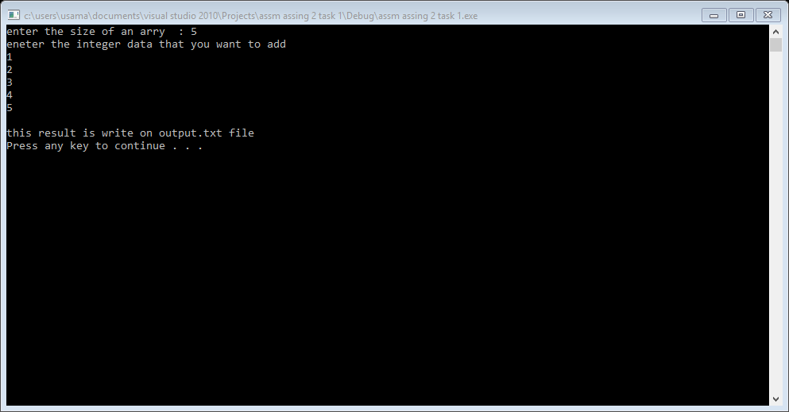

Task 2:

#include<iostream>

using namespace std;

int compstr(char *str1,char *str2,int size);

int main()

{

char arr1[100]={0},arr2[100]={0};

char *str1=NULL,*str2=NULL;

int size=0,fun=0;

str1=arr1;

str2=arr2;

cout<<"enter the size of of string : ";

cin>>size;

cout<<"enter the character of firat string "<<endl;

for(int i=0; i<size; i++)

{

cin>>*(str1+i);

}

cout<<"enter the character of second string "<<endl;

for(int i=0; i<size; i++)

{

cin>>*(str2+i);

}

fun=compstr(str1,str2,size);

if(fun==0)

{

cout<<"both strings are equal "<<endl;

}

else if(fun==-1)

{

cout<<str1<<" cames first alphabaticaly than "<<str2<<endl;

}

else if(fun==1)

{

cout<<str2<<" cames first alphabaticaly than "<<str1<<endl;

}

else

{

cout<<" your function not work properly "<<endl;

}

system("pause");

return 0;

}

int compstr(char *str1,char *str2,int size)

{

for(int i=0; *(str1+i)!=NULL && *(str2+i)!=NULL ; i++)

{

if((*(str1+i))>(*(str2+i)))

{

return 1;

}

if((*(str1+i))<(*(str2+i)))

{

return -1;

}

}

return 0;

}

Result:

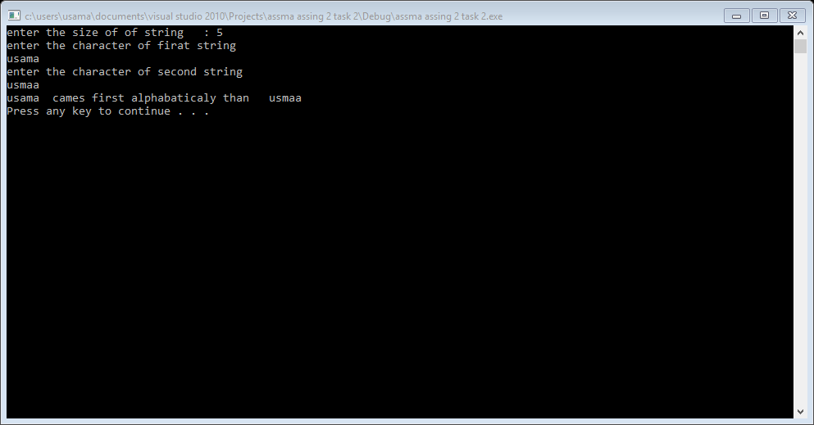

Result:

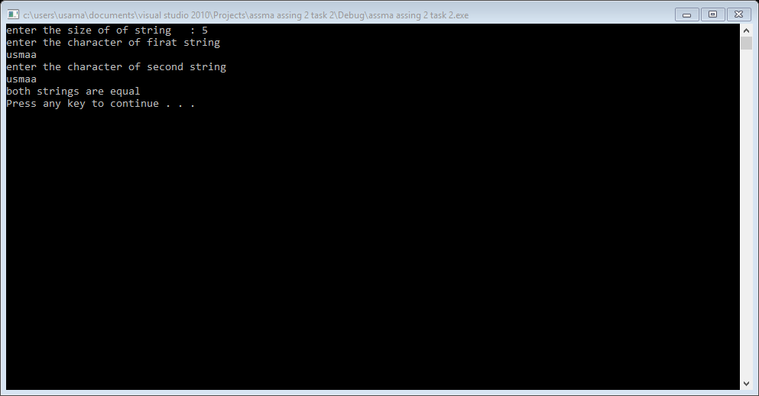

Result:

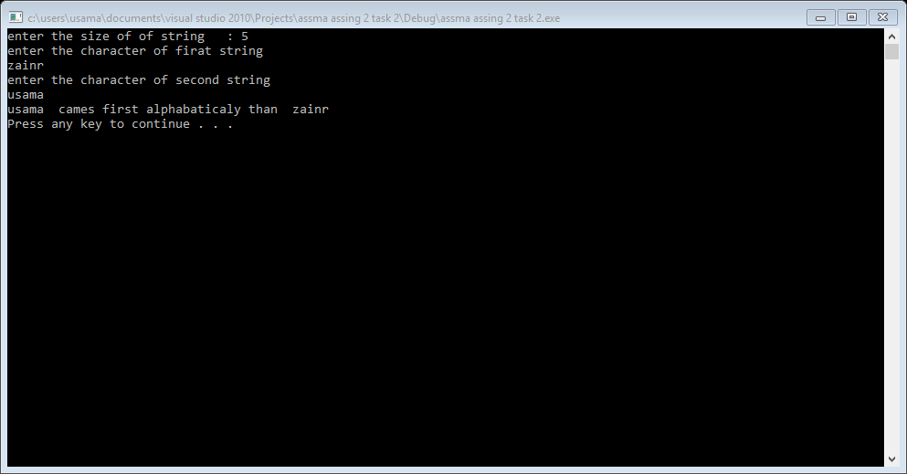

Task 3:

#include<iostream>

#include<iomanip>

using namespace std;

void print();

void input();

void sumptr();

void reverse();

void swap();

int arry[1000]={0};

int size=0,sum=0;

int *ptr=&arry[0];

int main()

{

cout<<"enetr the siz eof the arry "<<endl;

cin>>size;

char ch=0;

input();

cout<<"press r to reverse the array\npress s for swaping the array\npress a for both operation "<<endl;

cin>>ch;

print();

sumptr();

if(ch=='r')

{

reverse();

}

else if(ch=='s')

{

swap();

}

else if(ch=='a')

{

reverse();

swap();

}

else

{

cout<<"you press in valid operation"<<endl;

}

system("pause");

return 0;

}

void input()

{

for(int i=0; i<size; i++)

{

cout<<"enetr "<<i+1<<" elemnet in the arry : ";

cin>>*(ptr+i);

}

}

void print()

{

cout<<"you enter this no in the list : ";

for(int i=0; i<size; i++)

{

cout<<*(ptr+i)<<setw(5);

}

cout<<endl;

}

void sumptr()

{

for(int i=0; i<size; i++)

{

sum=sum+*(ptr+i);

}

cout<<"sum of totall no that you enter : "<<sum<<endl;

}

void reverse()

{

int temp=0;

for(int i=0; i<size/2; i++)

{

temp=*(ptr+i);

*(ptr+i)=*(ptr+((size-1)-i));

*(ptr+((size-1)-i))=temp;

}

cout<<"after reversing the contact of your list : ";

for(int i=0; i<size; i++)

{

cout<<ptr[i]<<setw(5);

}

cout<<endl;

}

void swap()

{

int temp=0,k=0;

for(int i=0; i<size; i++)

{

if(i+2>=size)

{

break;

}

if(i%2==0)

{

temp=*(ptr+i);

*(ptr+i)=*(ptr+i+2);

*(ptr+i+2)=temp;

i=i+3;

}

}

for(int i=0

; i<size; i++)

{

if(i+2>=size)

{

break;

}

if(i%2!=0)

{

temp=*(ptr+i);

*(ptr+i)=*(ptr+i+2);

*(ptr+i+2)=temp;

i=i+3;

}

}

cout<<"after swaping the element of an arry : ";

for(int i=0; i<size; i++)

{

cout<<*(ptr+i)<<setw(5);

}

cout<<endl;

}

Result 1:

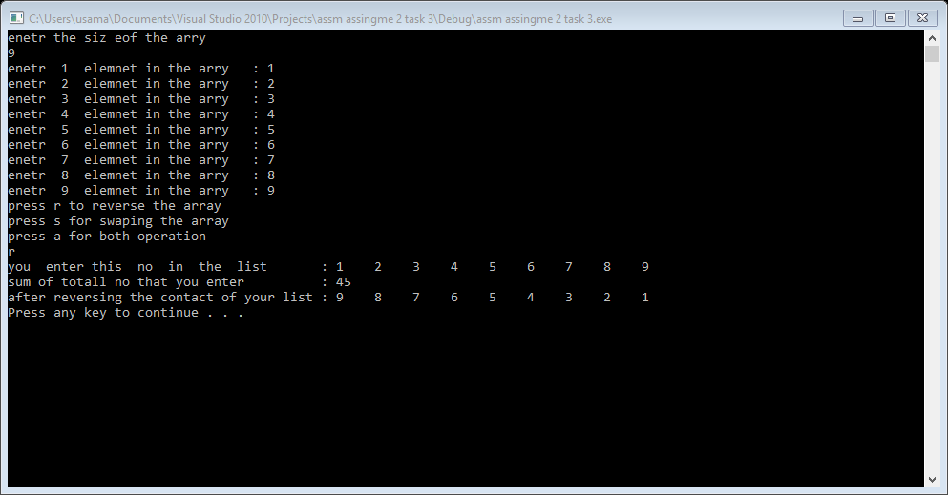

Result 2:

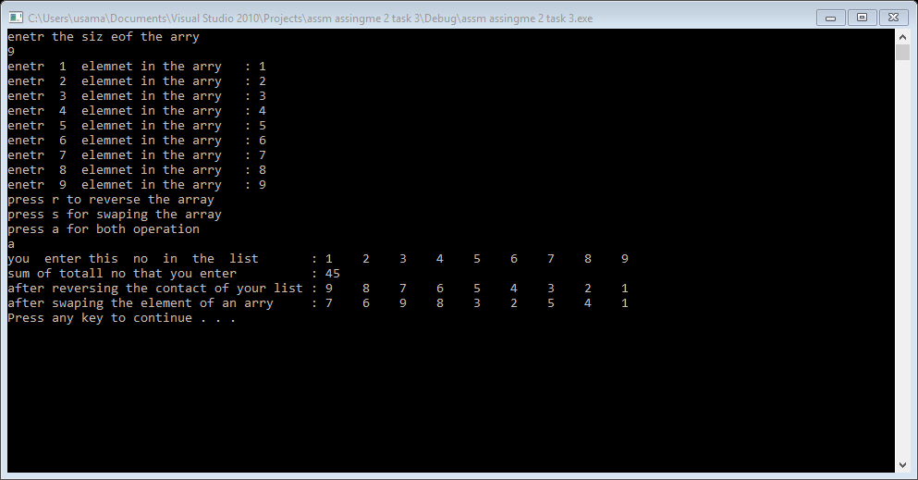

Task 4:

#include<iostream>

#include<iomanip>

#include<fstream>

using namespace std;

void add();

void sub();

void mul();

void addit();

void substrac();

void multiplication();

int matrix1[3][3]={0};

int matrix2[3][3]={0};

int multi[3][3]={0};

int addition[3][3]={0};

int substraction[3][3]={0};

int (*ptr1)[3]=matrix1;

int (*ptr2)[3]=matrix2;

int (*multip)[3]=multi;

int (*addi)[3]=addition;

int (*subs)[3]=substraction;

ifstream read;

ofstream write;

int main()

{

char decision;

bool again=true;

cout<<"enter 2 matrix of 3*3 "<<endl;

cout<<"enetr 1st matrix "<<endl;

for(int i=0; i<3; i++)

{

for(int j=0; j<3; j++)

{

cin>>*(*(ptr1+i)+j);

}

cout<<endl;

}

cout<<"enetr 2st matrix "<<endl;

for(int i=0; i<3; i++)

{

for(int j=0; j<3; j++)

{

cin>>*(*(ptr2+i)+j);

}

cout<<endl;

}

cout<<"you enter 1st matrix is "<<endl;

for(int i=0; i<3; i++)

{

for(int j=0; j<3; j++)

{

cout<<setw(5)<<*(*(ptr1+i)+j);;

}

cout<<endl;

}

cout<<"you enter 2st matrix is "<<endl;

for(int i=0; i<3; i++)

{

for(int j=0; j<3; j++)

{

cout<<setw(5)<<*(*(ptr2+i)+j);;

}

cout<<endl;

}

while(again==true)

{

cout<<"press M for multiplication \npress S for subtraction\npress A for addition"<<endl;

cin>>decision;

if(decision=='m'||decision=='M')

{

system("cls");

mul();

again=false;

}

else if(decision=='s'||decision=='S')

{

system("cls");

sub();

again=false;

}

else if(decision=='a'||decision=='A')

{

system("cls");

add();

again=false;

}

else

{

cout<<"you press invalid key"<<endl;

}

cout<<"press A for again\nelse press any key : ";

cin>>decision;

if(decision=='a'||decision=='A')

{

again=true;

}

}

system("pause");

return 0;

}

void add()

{

cout<<"sum of matrix is "<<endl;

for(int i=0; i<3; i++)

{

for(int j=0; j<3; j++)

{

*(*(addi+i)+j)=*(*(ptr1+i)+j)+*(*(ptr2+i)+j);

cout<<setw(3)<<*(*(addi+i)+j);

}

cout<<endl;

}

addit();

}

void sub()

{

int d=0;

cout<<"prees 1 to subtract from 1st matrix to 2nd matrix\npress 2 to subtract 2nd matrix to 1st matrix "<<endl;

cin>>d;

if(d==1)

{

cout<<"subtraction of matrix is "<<endl;

for(int i=0; i<3; i++)

{

for(int j=0; j<3; j++)

{

*(*(subs+i)+j)=*(*(ptr1+i)+j)-*(*(ptr2+i)+j);

cout<<setw(5)<<*(*(subs+i)+j);

}

cout<<endl;

}

}

else if(d==2)

{

for(int i=0; i<3; i++)

{

for(int j=0; j<3; j++)

{

*(*(subs+i)+j)=*(*(ptr2+i)+j)-*(*(ptr1+i)+j);

cout<<setw(5)<<*(*(subs+i)+j);

}

cout<<endl;

}

}

else

{

cout<<"illegal operation"<<endl;

}

substrac();

}

void mul()

{

for(int i=0; i<3; i++)

{

for(int j=0; j<3; j++)

{

for(int k=0; k<3; k++)

{

*(*(multip+i)+j)=*(*(multip+i)+j)+(*(*(ptr1+i)+k))*(*(*(ptr2+k)+j));

}

}

}

cout<<"multiplication of two matrix"<<endl;

for(int i=0; i<3; i++)

{

for(int j=0; j<3; j++)

{

cout<<setw(10)<<*(*(multip+i)+j);

}

cout<<endl;

}

multiplication();

for(int i=0; i<3; i++)

{

for(int j=0; j<3; j++)

{

*(*(multip+i)+j)=0;

}

}

}

void addit()

{

write.open("result.txt");

if(write.is_open())

{

for(int i=0; i<3; i++)

{

for(int j=0; j<3; j++)

{

write<<setw(5)<<*(*(addi+i)+j);

}

}

}

else

{

cout<<"file not open "<<endl;

}

}

void substrac()

{

write.open("result.txt");

if(write.is_open())

{

for(int i=0; i<3; i++)

{

for(int j=0; j<3; j++)

{

write<<setw(5)<<*(*(subs+i)+j);

}

}

}

else

{

cout<<"file not open "<<endl;

}

}

void multiplication()

{

write.open("result.txt");

if(write.is_open())

{

for(int i=0; i<3; i++)

{

for(int j=0; j<3; j++)

{

write<<setw(10)<<*(*(multip+i)+j);

}

}

}

else

{

cout<<"file not open "<<endl;

}

}

Result:

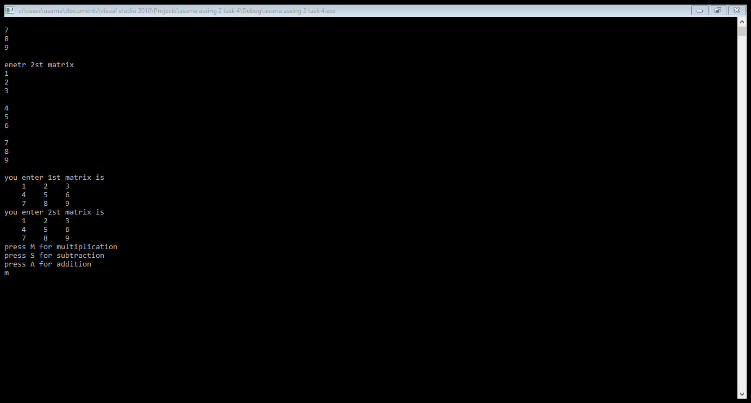

Result:multiplication: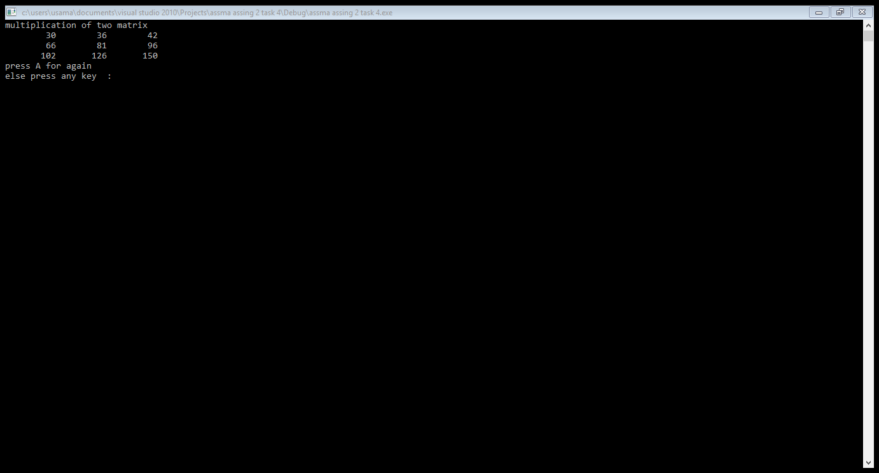

Result:addition:

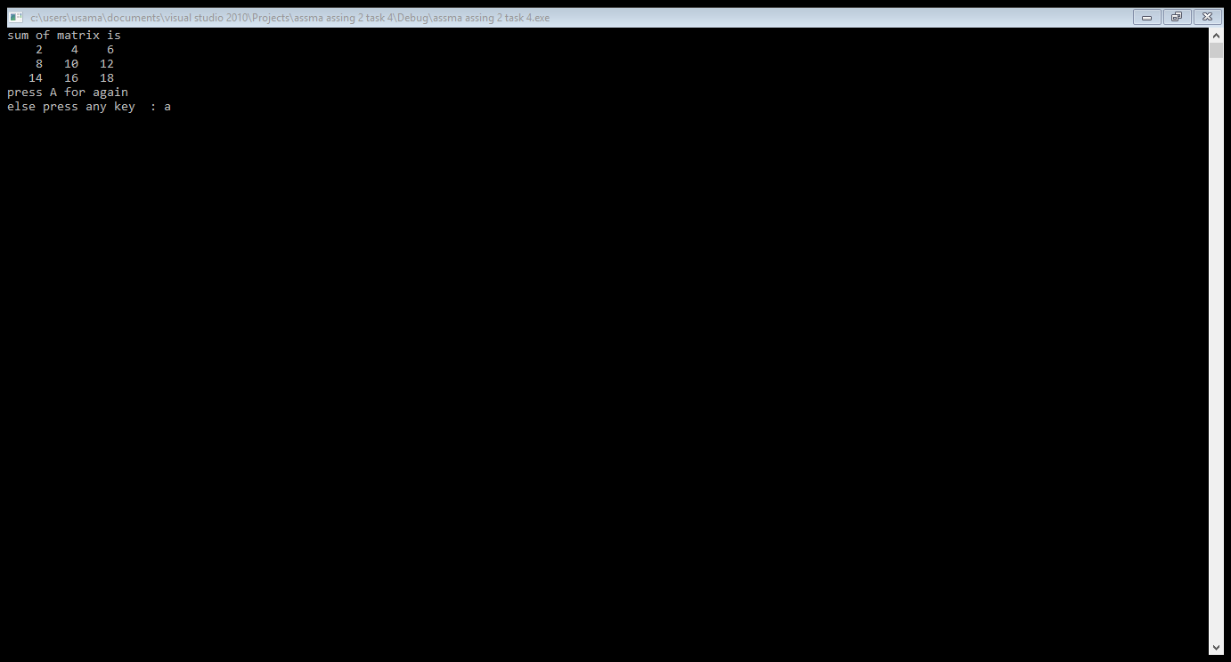

Task 5::part A:

yes, array cannot be incremented because array store base address that is constant that cannot be incremented to access the next address value as pointers. On the other hand pointers store memory if we increment pointers value then it points or access to next address value. So, we can operation increment operation in pointers but not in arrays.

Task 5::part B:

#include<iostream>

using namespace std;

int main()

{

int *ptr=NULL;

int arr[10]={0};

ptr=arr;

for(int i=0; i<10; i++)

{

cout<<"enter "<<i+1<<" element of arry : ";

cin>>*ptr;

ptr++;

}

/*when we do input by incrementing the addres of ptr then

we already reached on last addres of arry and now we need

to go to the base addres of arry then we can cout the value

of arry then we gat correct answer. otherwise in this way

we go outside of arry size and we get wrong answer.

for(int i=0; i<10; i++)

{

cout<<i+1<<" element of arry : ";

cout<<*ptr;

ptr++;

cout<<endl;

}*/

//in this way we get correct answer.

ptr=arr;

for(int i=0; i<10; i++)

{

cout<<i+1<<" element of arry : ";

cout<<*ptr;

ptr++;

cout<<endl;

}

system("pause");

return 0;

}

Result:

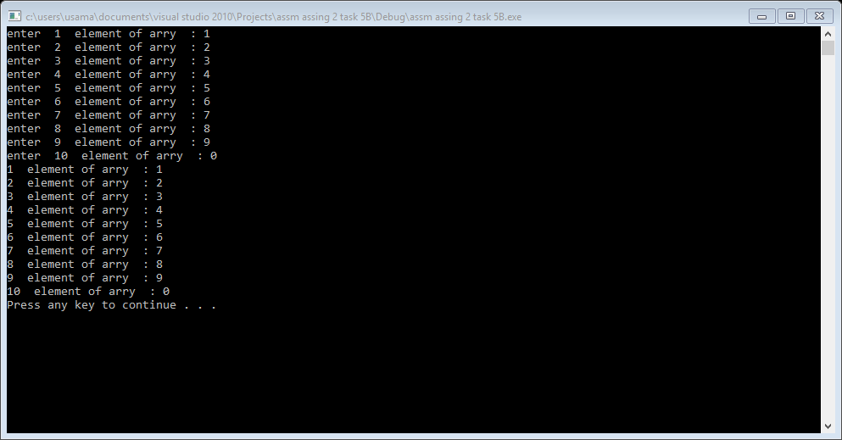

Task 5::part C:

#include<iostream>

using namespace std;

int main()

{

int a=4,b=8;

int* ptr=NULL;

int* qtr=NULL;

ptr=&a;

qtr=&b;

int**dptr=&ptr;

cout<<"addres of A : "<<&a<<" value of A : "<<a<<endl;

cout<<"addres of ptr : "<<ptr<<" value of *ptr : "<<*ptr<<endl;

cout<<"addres of dptr : "<<dptr<<" value of *dpyr : "<<*dptr<<" value of **dptr : "<<**dptr<<endl;

cout<<"addres of B : "<<&b<<" value of B : "<<b<<endl;

cout<<"addres of qtr : "<<qtr<<" value of *qtr : "<<*qtr<<endl;

system("pause"); return 0;}

Result::

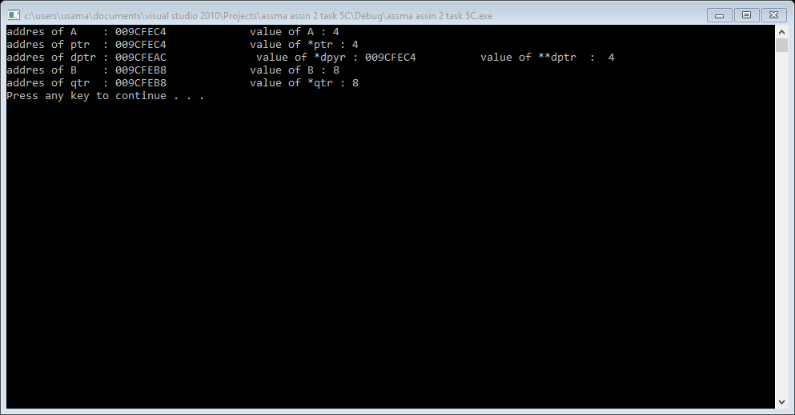

Task::5:part D:

#include<iostream>

using namespace std;

int main()

{

int x=0,y=0,z=0;

int *p=NULL,*q=NULL,*r=NULL;

cout<<"enter value of x : ";

cin>>x;

cout<<endl;

cout<<"enter value of y : ";

cin>>y;

cout<<endl;

cout<<"enter value of z : ";

cin>>z;

cout<<endl;

p=&x;

q=&y;

r=&z;

cout<<"value of x : "<<x<<endl;

cout<<"value of y : "<<y<<endl;

cout<<"value of z : "<<z<<endl;

cout<<"value of p : "<<p<<endl;

cout<<"value of q : "<<q<<endl;

cout<<"value of r : "<<r<<endl;

cout<<"value of *p : "<<*p<<endl;

cout<<"value of *q : "<<*q<<endl;

cout<<"value of *r : "<<*r<<endl;

cout<<endl;

cout<<"swaping pointers"<<endl;

cout<<endl;

r = p;

p = q;

q = r;

cout<<"value of x : "<<x<<endl;

cout<<"value of y : "<<y<<endl;

cout<<"value of z : "<<z<<endl;

cout<<"value of p : "<<p<<endl;

cout<<"value of q : "<<q<<endl;

cout<<"value of r : "<<r<<endl;

cout<<"value of *p : "<<*p<<endl;

cout<<"value of *q : "<<*q<<endl;

cout<<"value of *r : "<<*r<<endl;

system("pause");

return 0;

}

Result:

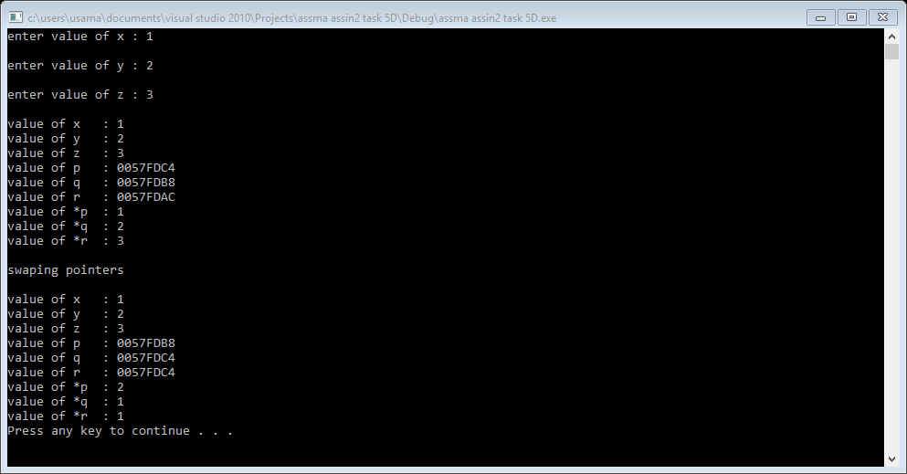

Task 5::part E:

#include<iostream>

using namespace std;

int main()

{

char s[100]="hippopotamus";

char* p=s;

*p='x'; //assign x in the 0 index

*(p++)='b'; //assign b in the 1 index

*(p+2)='y'; //assign y in the 4 index

(*p)++;

while((*p++)!='t')

{

cout<<*p; //now it print from 2nd index or 3rd element of array untill t.

}

system("pause");

return 0;

}

Result:

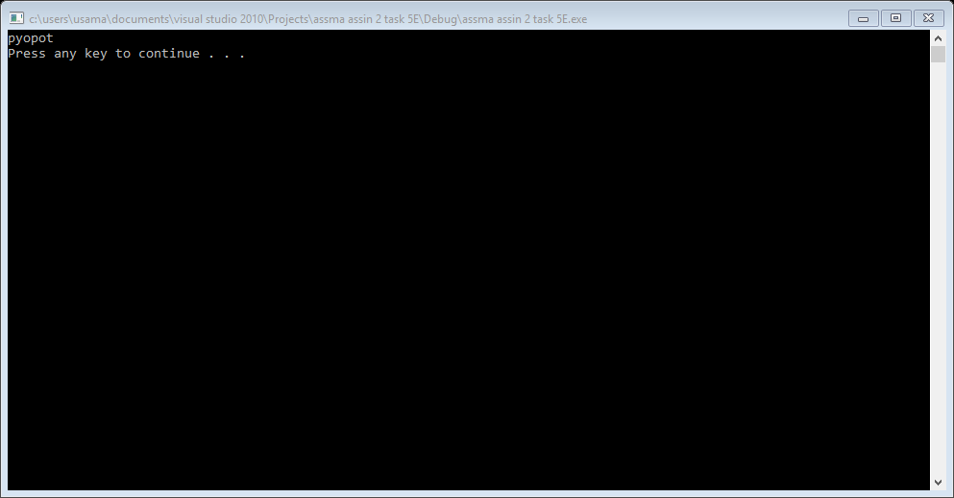

Task :6

#include<iostream>

using namespace std;

int main()

{

int arry[5]={1,2,3,4,5};

void *ptr=arry;

int l=0;

/*void mean no type so we need to convert the pointer in the

data type of the variable to which pointer is pointing */

for(int i=0; i<5; i++)

{

cout<<*((int*)ptr+i)<<endl;

l=i;

}

//last index address of arry is.

cout<<"last index address is : "<<((int*)ptr+l)<<endl;

system("pause");

return 0;

}

Result:

